GIFT TO NTUADF
Please scan the QR Code to donate online

National Taiwan University Academic Development Foundation (NTUADF) was established by NTU alumni to support the advancement of our alma mater. The foundation cooperates closely with NTU and receives a U.S. tax exempt status (NTUADF’s Tax ID number is 36-4221899) and all gifts made to NTUADF are tax deductible in the U.S.
Donor English Name Receipt Title □same as Donor
If NTU alumnus: □ NO □ Graduation Year School/Dpt. Mailing Address Tel E-mail

□The First Hall or Zhung Fei Building Restoration Fund (FN108018)
□Diligence Fellowship Fund of the Department of Plant Pathology and Microbiology (FS1020004)
□Fund of the Department of Plant Pathology and Microbiology (91F006)
□Prof. SU, Hong-Ji Memorial Scholarship Fund of the Department of Plant Pathology and Microbiology (FS109009)
□Alumni Fund of the Department of Plant Pathology and Microbiology (FD106012)
□Other programs

□Online Credit Card/Debit Card/PayPal Donation,
Please visit https://giving.ntu.edu.tw to make donation online.
□One-time □Monthly □Quarterly □Annual, USD
□Check or Money Order, USD
Please make the check payable to "NTUADF" and mail it together with this form.

□Wire Transfer, Marketable Securities and/or Mutual Fund Shares
Please contact NTUADF (ntuadf@gmail.com) or NTU for more information.
□Company Matching Funds
Please contact NTUADF (ntuadf@gmail.com) or NTU for more information.

Please let us know if you’d like your gift remain confidential.
□ok to publicize (default) □make it anonymous, but open to the donee □make it anonymous strictly
How would you like your thank-you letter?
□an email □a letter □I don’t need it
Where do you get this donation information?
□Donation Letter □NTU e-paper □NTU Alumni Bimonthly □NTU donation website
□Alumni □Others

Our office abides by regulations concerning the protection of personal information and will properly protect your information. All information will remain within this office and donors may verify, search, copy, supplement, update, delete and stop this information whenever they wish.

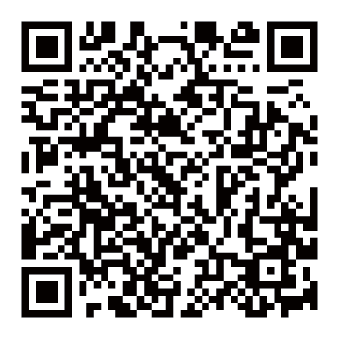NTUADF
Dr. Ching-Chong Huang 黃慶鍾醫師, Treasurer of NTUADF 38 Ridgefield Lane, Willowbrook, Illinois 60527
Tel: 630-569-3701
ntuadf@gmail.com
NTU Office of Financial Affairs
Ms. Shiang-Ting Wang Tel: +886-2-3366-9799
redrootwang@ntu.edu.tw

